Coaxial Cable

📡 What Is a Coaxial Cable?
# Source: Chatgpt (GPT‑5 Mini) at [12/18/2025]
A Coaxial Cable (or coax cable) is a type of electrical cable used to transmit data, video, or radio frequency signals. It has a central conductor surrounded by insulating layers and shielding, which helps reduce interference and signal loss.

Coaxial Cable photo
# Source: Windows Screenshots (using Lightshot Program) at [12/18/2025]
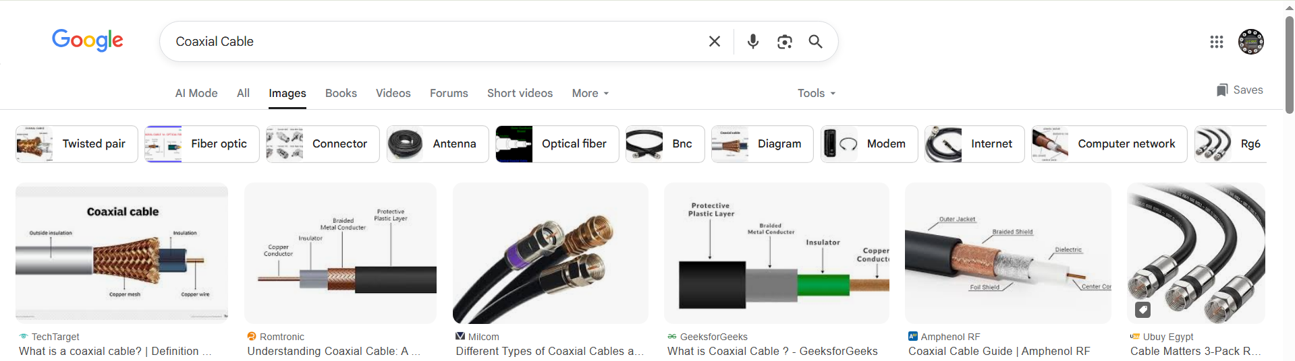

📦 Belongs to:
# Source: Chatgpt (GPT‑5 Mini) at [12/18/2025]
✅ Types of Network Cables
Specifically under wired (copper-based) transmission media.

🧠 Key Structure
# Source: Chatgpt (GPT‑5 Mini) at [12/18/2025]
Coaxial cables have four main layers:

[Outer Jacket] → [Metal Shield] → [Insulator] → [Inner Copper Conductor]\

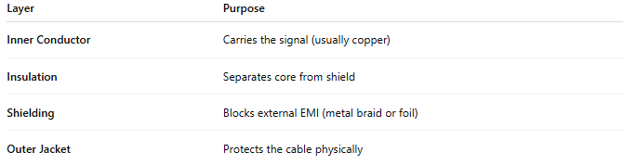

Layer | Purpose
Inner Conductor | Carries the signal (usually copper)
Insulation | Separates core from shield
Shielding | Blocks external EMI (metal braid or foil)
Outer Jacket | Protects the cable physically

🔌 Common Types of Coaxial Cable
# Source: Chatgpt (GPT‑5 Mini) at [12/18/2025]

Type | Use Case
RG-6 | Cable TV, internet (modern standard)
RG-59 | Analog CCTV (short distances)
RG-11 | Long-distance video transmission
RG-58 | Legacy Ethernet (10BASE2 networks)

🧾 Common Uses
- 📺 Cable television (CATV)
- 🌐 Broadband internet (DOCSIS cable modems)
- 📹 Analog CCTV surveillance
- 📻 Satellite and radio frequency systems
- 📡 Early Ethernet networks (10BASE2 and 10BASE5 – now outdated)

✅ Advantages
# Source: Chatgpt (GPT‑5 Mini) at [12/18/2025]
- 🛡️ Good shielding against EMI
- 📏 Supports longer distances than unshielded twisted pair (UTP)
- ⚡ Can carry both data and power (in some configurations)
- 🛠️ Easy to find and install

❌ Disadvantages
# Source: Chatgpt (GPT‑5 Mini) at [12/18/2025]
- 🧓 Becoming less common in modern LANs (replaced by Ethernet/fiber)
- 🔁 Less flexible for frequent changes or upgrades
- ⚡ Lower data rates than fiber or modern Ethernet for LAN use

📌 Summary
# Source: Chatgpt (GPT‑5 Mini) at [12/18/2025]
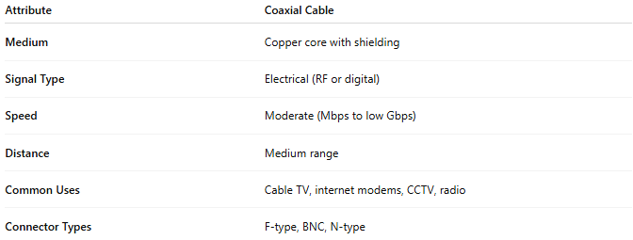
Attribute | Coaxial Cable
Medium | Copper core with shielding
Signal Type | Electrical (RF or digital)
Speed | Moderate (Mbps to low Gbps)
Distance | Medium range
Common Uses | Cable TV, internet modems, CCTV, radio
Connector Types | F-type, BNC, N-type

